CSCI 5010 – Fundamentals of Data Communications

Lab 1

Internet Speed Test & Computer Command Prompt

University of Colorado Boulder

Department of Computer Science

Network Engineering

Professor Levi Perigo, Ph.D.

# Summary

This lab is intended to be an overview of Internet speed testing technologies and scenarios, as well as basic Operating Systems (OS) (Windows and Mac) command prompt utilization. This lab will be a baseline for future exploration into these topics used throughout this course.

The questions in the lab are intentionally vague. The purpose of this is for you not only to research, investigate, and learn the technologies, but also become proficient at interpreting both non-technical and technical questions. Being able to research and discover answers on your own will be critical as you progress in your career.

# Objective 1: Internet Speed Testers

There are various ways to test Internet connectivity speeds from your device. In this objective, you will utilize different applications and technologies to evaluate differences in speed tests.

1. Select three (at least one of the three should be from an ISP (i.e. Comcast)) free, online Internet speed test sites (*Note: be careful where you click on some sites, as there are often malicious adds on free testing sites*).
   1. Provide a screenshot of the results/summary page from each site. [**6 points**]
2. www.speedtest.net

1. speedtest.xfinity.com

1. fast.com

* 1. Were the results from the various sites the same or different? Why? [**2 points**]

The results from the various sites were different. There could be a handful of reasons why they could differ like. First, this was a wireless test and there could be slight differences in the RF at certain times. Also I could be testing my speed from different servers on the various speed test websites.

1. Choose your favorite testing site, used previously, to use again. (www.speedtest.net)
   1. Find a location where you can use either a wired or wireless connection.
      1. Run the speed test on wireless. Provide a screenshot of the results. [**2 points**]

* + 1. Run the speed test on wired. Provide a screenshot of the results. [**2 points**]

* + 1. Were the results different? Why or why not? [**2 points**]

The results were different. I think the results were different because a wired ethernet connection is more reliable and can provide the true speed of the ISP because the data is running through a copper wire as opposed to RF.

* 1. Run the speed test at a different location (on campus, home, coffee shop). Were the results better or worse than your other tests? Why? [**2 points**]

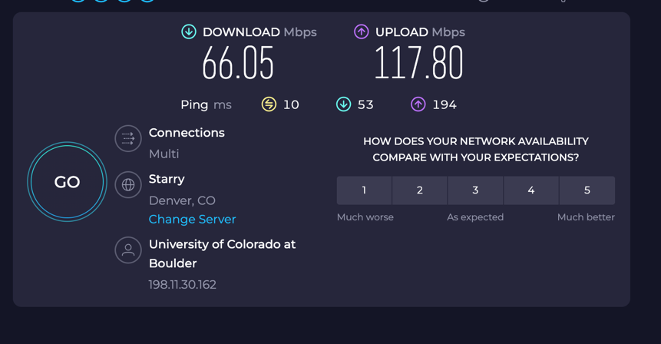

They were worse and better. They were better with their upload speed because they could be paying for a high upload speed. They were worse with their download speed because I pay for a high download speed.

1. List three benefits of obtaining accurate Internet speed test results. [**5 points**]
2. It can determine whether you will be able to stream video consistently and reliably.
3. It can determine whether you are getting the speed you are paying for by your ISP.
4. It can determine if there is a problem with either your internet connection or ISP.
5. What are three best practices to obtain accurate Internet speed test results? [**5 points**]
6. Have a wired ethernet connection.
7. Make sure no other devices are using bandwidth on the network.
8. Use a device with a NIC that allows for the highest speed possible
9. Explain the following concepts, and how they are used with speed tests? [**2 points each**]
   1. Ping (Latency) Test
      1. Ping is how fast in milliseconds it takes for data to travel from a computer to a desired server. They are used with speed tests to see how fast the data can reach the server or ISP.
   2. Download Test
      1. The download tests measures how many bits of information can be transferred each second to the user, the unit being mbps (megabits per second). Download test is used in speed tests to determine how many bits of information you can download with your ISPs plan.
   3. Upload Test
      1. The upload tests measure how many bits of information can be transferred each second to the server, the unit being mbps (megabits per second). Upload test is used in speed tests to determine how many bits of information you can upload to the internet.
   4. Is TCP or UDP used? Why?
      1. According to [speedtest.net](https://help.speedtest.net/hc/en-us/articles/360038679354-How-does-Speedtest-measure-my-network-speeds-#:~:text=Speedtest.net%20operates%20mainly%20over,download%20speed%20and%20upload%20speed.), TCP is mainly used for the speed test. It is used over UDP because it is a better simulation of network traffic than UDP.
10. If the results of your speed test is lower than what you expect/pay for from your ISP, list two things you could do to troubleshoot the connection/speed before you contact the ISP? [**2 points**]
    * 1. The first thing I would do is restart the modem/router, and make sure it has its latest firmware.
      2. Make sure you have a wired ethernet connection as opposed to a wireless connection
    1. After troubleshooting, if you determine your Internet speed is lower than what you expect from your ISP, list three ways you could potentially boost your Internet speed, and explain each. [**6 points**]
       1. The first way to potentially boost your internet speed is instead of using wireless, use a wired connection directly to the internet source. This will guarantee a reliable connection directly to the internet.
       2. If you can’t get a wired connection, then connecting to the wireless at a higher frequency, if possible, could boost the internet speed. Higher frequencies can carry more bits per second and could increase internet speed.
       3. If you have an older machine, your NIC or network interface card could be of a spec that limits the true speed the ISP provides. Upgrading your NIC could allow for your machine to use the full posted speed of your ISP.

# Objective 2 – Command Prompt (Windows/Mac)

# The command line, also known as cmd or shell, is used by system administrators to quickly interact with a machine, without having to click through numerous graphic menus. This objective will provide the useful commands that are needed for networking and information gathering on a computer, such as IP address, MAC address, default-gateway, DNS, ARP table, and IP connectivity.

1. Basic Networking Information
   1. Open the command prompt
      1. **Windows users:** The easiest way to achieve this in Windows is to type “cmd” + <enter> in the Windows search bar.

**Mac users:** Use the Finder to go to Applications > Utilities > Terminal.

What is another way you can find the command prompt on your windows/mac machine? List the steps. [**2 points**]

On a mac machine, you can simply press command + space bar to open the search function and type in terminal + <enter>.

On a windows machine, you simply right click the windows button in the bottom left corner to open a drop down menu where terminal will be listed as an option, click that and terminal will open.

* + 1. Issue a single command that will indicate all of the following information. Provide a screenshot of the command output [**3 points**], as well as answer the following questions based on the output [**1 point each**]:
       1. What is your machine’s IP address?

192.168.1.9

* + - * 1. Is it static or dynamic (DHCP)?

Dynamic

What is the difference between static/dynamic?

Static is when your IP does not change, and dynamic is when the network assigns your IP address and can change over time.

* + - * 1. What layer of the OSI model is an IP address?

An IP address exists at Layer 3 on the OSI model.

* + - * 1. Which NIC are you using (wired/wireless)? Indicate this.

Wired

* + - 1. What is your machine’s default-gateway address?

192.168.1.1

* + - * 1. What is the purpose of a default-gateway?

The purpose of the default-gateway in my network is that is the address of my home router. That is the address that takes my traffic and sends it off into the internet to where it needs to go.

* + - 1. List the DNS server(s).

192.168.1.1

* + - * 1. What is the purpose of a DNS server?

A DNS server resolves the hostname of a website like google.com and converts it to an IP so a server can interpret that IP and give you the information of the website.

* + - 1. What is your MAC address of the NIC being used?  
         A8-A1-59-AC-A0-E5
         1. What layer of the OSI model is a MAC address?

The MAC address exists at Layer 2 on the OSI Model.

1. IP Connectivity
   1. Open the command prompt
      1. Ping [www.google.com](http://www.google.com). Provide a screenshot of the results [**2 points**], and answer the following questions based on the output [**1 point each**]:

* + - 1. What is ping?

Ping is a utility that allows for me to verify if I can reach a certain device on my network or somewhere on the internet. For example, in the above screenshot I verified that I could ping google.com and reach its server.

* + - 1. What is the IP address of Google?

142.250.72.68

* + - 1. What was the average round trip time for packets to reach Google’s server from your machine?

13ms

* + - 1. If you wanted to ping an IP address (or domain name) continuously, what parameter would you add to the ping command?

On my windows machine it is the parameter -t.

Ex: ping -t www.google.com

* + - * 1. How would you stop this continuous ping?

To stop the continuous ping, I pressed Ctrl + C

* + 1. Using the IP address of Google (obtained above), type this in your Internet browser’s URL. Does this resolve to [www.google.com](http://www.google.com)? Why or why not? [**2 points**]

It does resolve to www.google.com because that is the IP of the website. When we type in [www.google.com](http://www.google.com), the DNS server resolves this to name to the IP that we obtained by pinging Google.

* + 1. If you want to see how many Internet routers (hops) and the path your packet traverses to reach Google’s server, what command could you use? Provide a screenshot of the command and corresponding output. [**3 points**]

# Total Score = ________________/68